
Business Question and Visualization Report

Date | 1 November 2026
Team ID
Project Name | EV Market Performance & Insights Platform
Maximum Marks | 5 Marks

Visualization development refers to the process of creating graphical representations of data to facilitate understanding, analysis, and decision-making. The goal is to transform complex datasets into visual formats that are easy to interpret, enabling users to gain insights and make informed decisions. Visualization development involves selecting appropriate visual elements, designing layouts, and using interactive features to enhance the user experience. This process is commonly associated with data visualization tools and platforms, and it plays a crucial role in business intelligence, analytics, and reporting
Business Questions and Visualisation
The process involves defining specific business questions to guide the creation of meaningful and actionable visualizations in Tableau. Well-framed questions help in identifying key metrics, selecting relevant data, and building visualisation that provide insights.
1. What is the total sales volume generated across all EV models?
- Visualization: KPI Card / Big Number displaying total sales.
2. Which specific EV categories generate the highest total sales?
- Visualization: Horizontal Bar Chart comparing total sales across different vehicle categories (e.g., Compact SUV, Hatchback).
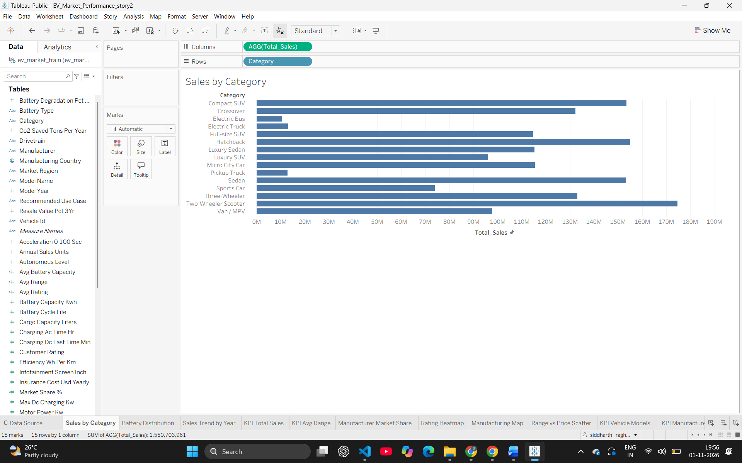3. What is the market share distribution of different battery technologies used in EVs?
- Visualization: Pie Chart showing the proportion of sales by battery type (LFP, NMC, Sodium-Ion, etc.).
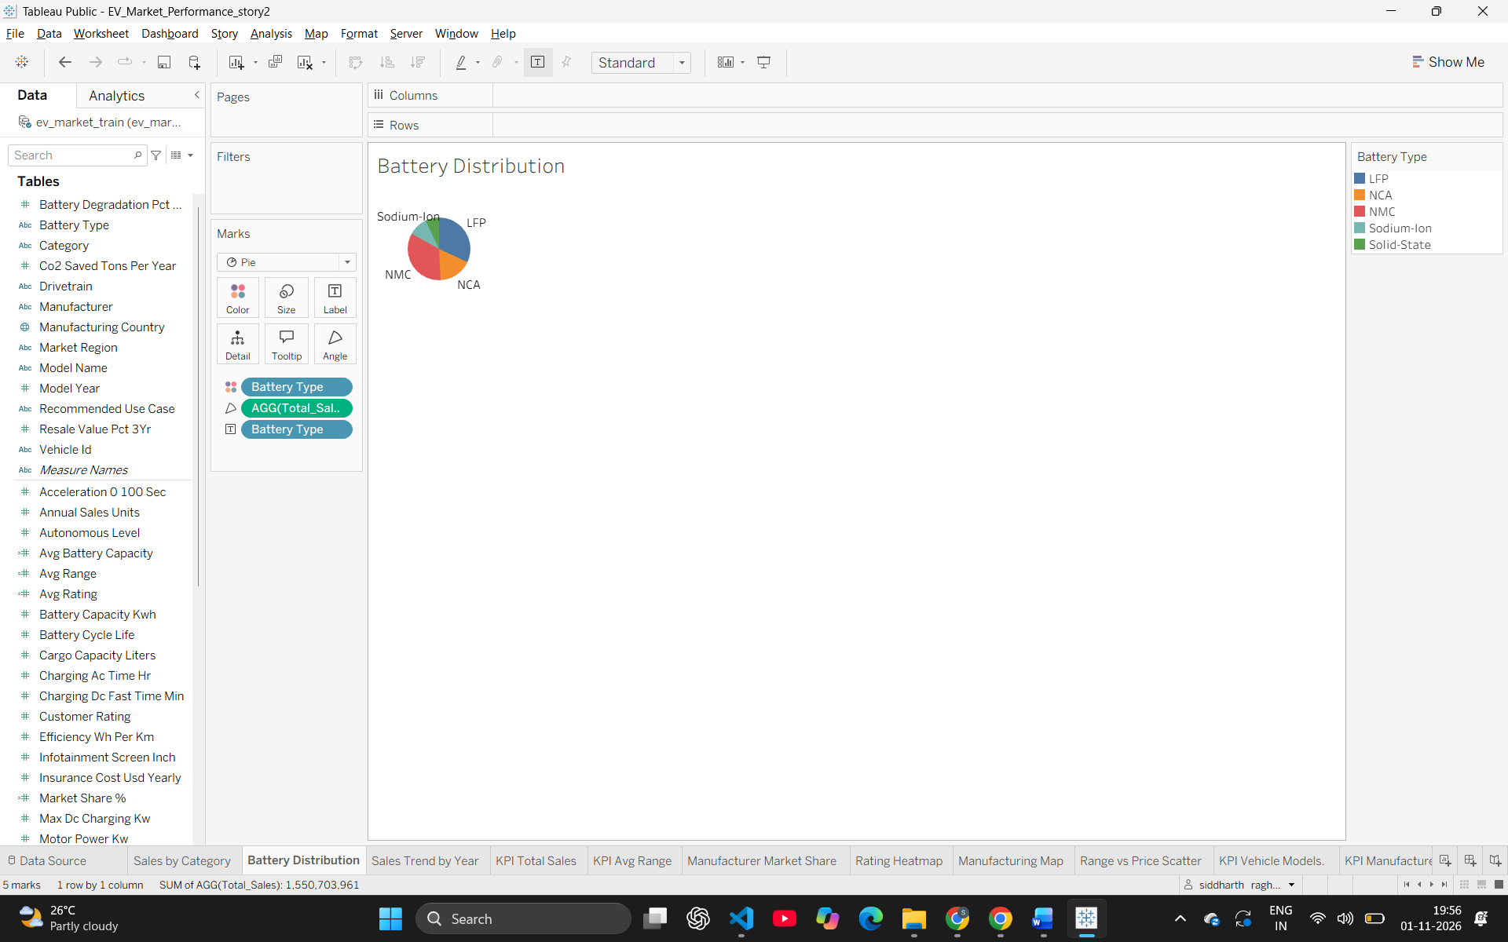4. Which manufacturers dominate the EV market share?
- Visualization: Donut Chart illustrating the percentage share of total sales by manufacturer.
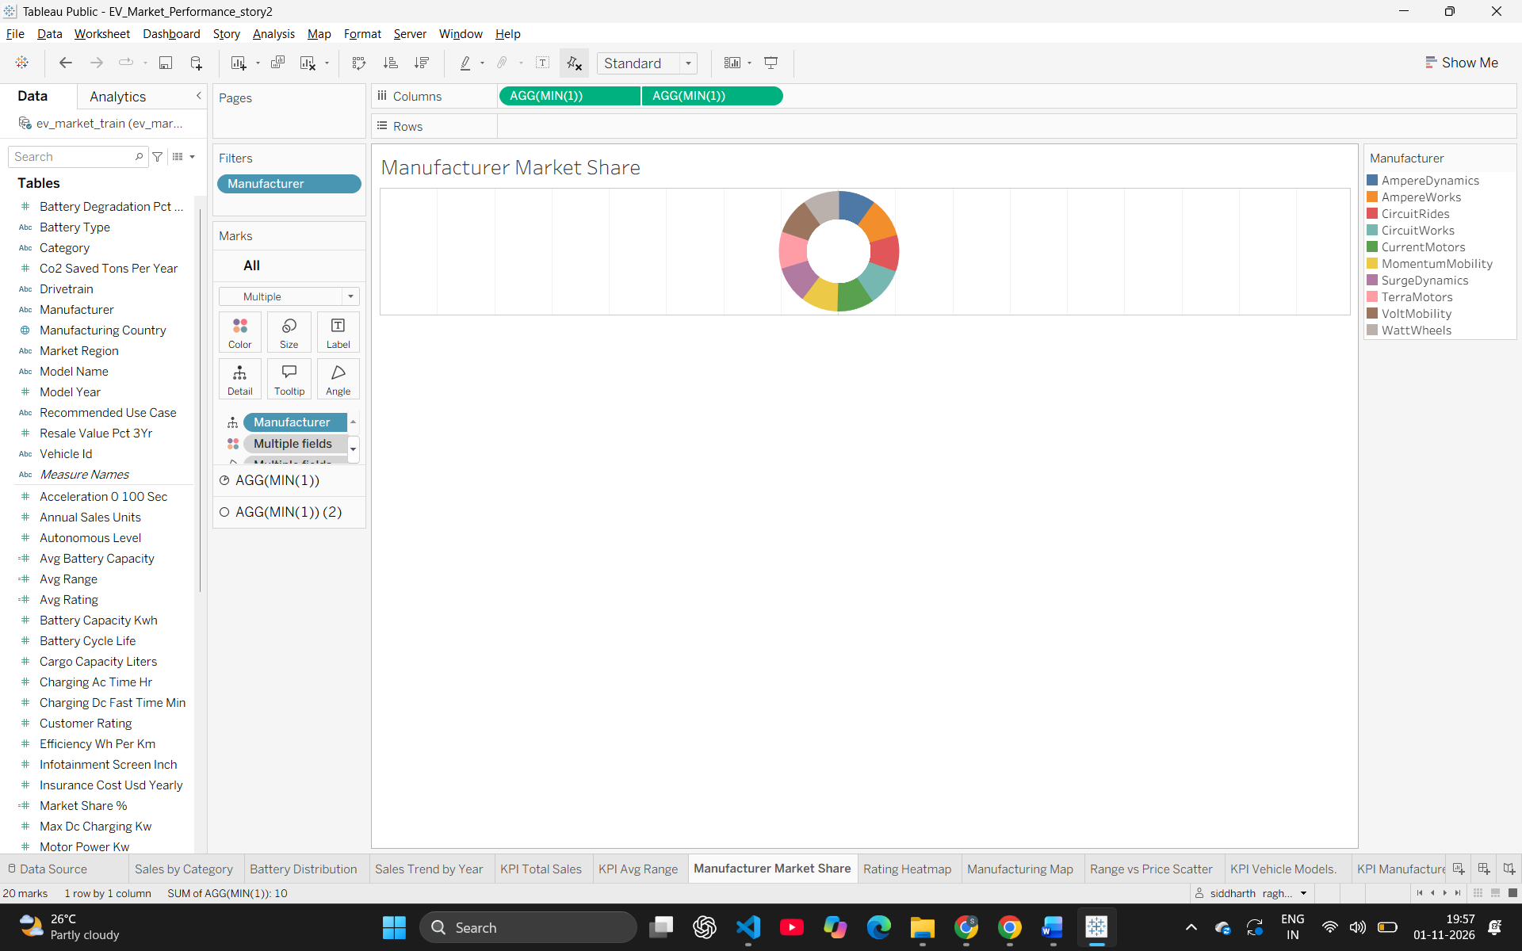5. How do customer ratings vary across different EV categories and battery types?
- Visualization: Heatmap using color intensity to show average ratings across rows (Battery Type) and columns (Category).
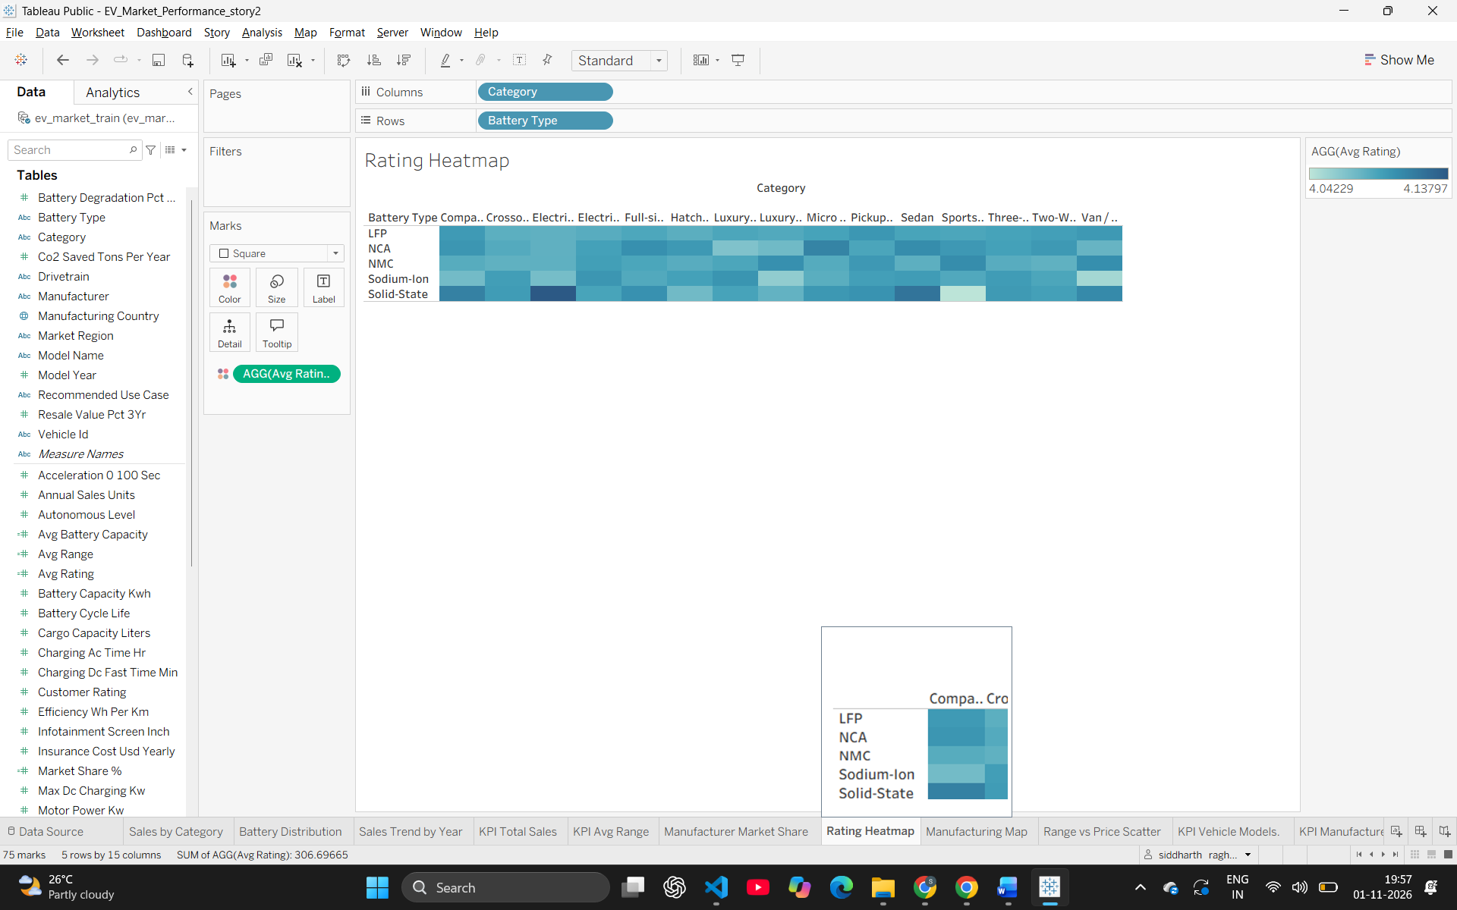6. How has the total sales trend evolved year-over-year from 2017 to 2026?
- Visualization: Line Chart tracking the continuous growth or decline of total sales over the model years.
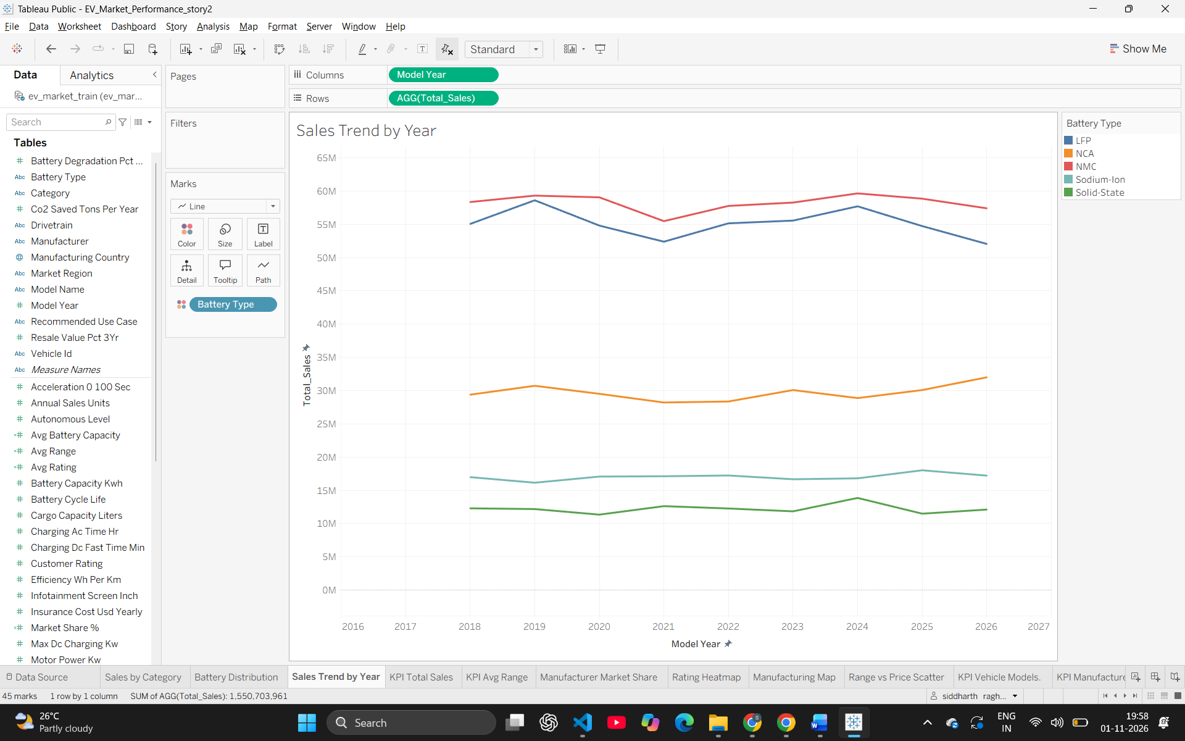7. Where are the primary global manufacturing hubs located for these EV models?
- Visualization: Filled Geographic Map highlighting the countries with the highest concentration of manufacturing.
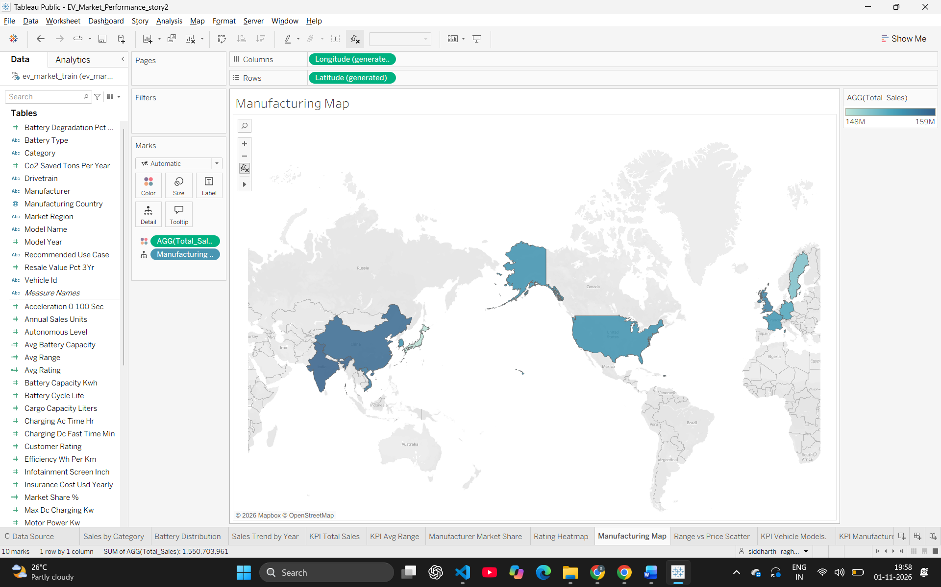8. What is the correlation between an EV's driving range and its selling price?
- Visualization: Scatter Plot with Range on the X-axis and Price on the Y-axis to identify clusters and trends.
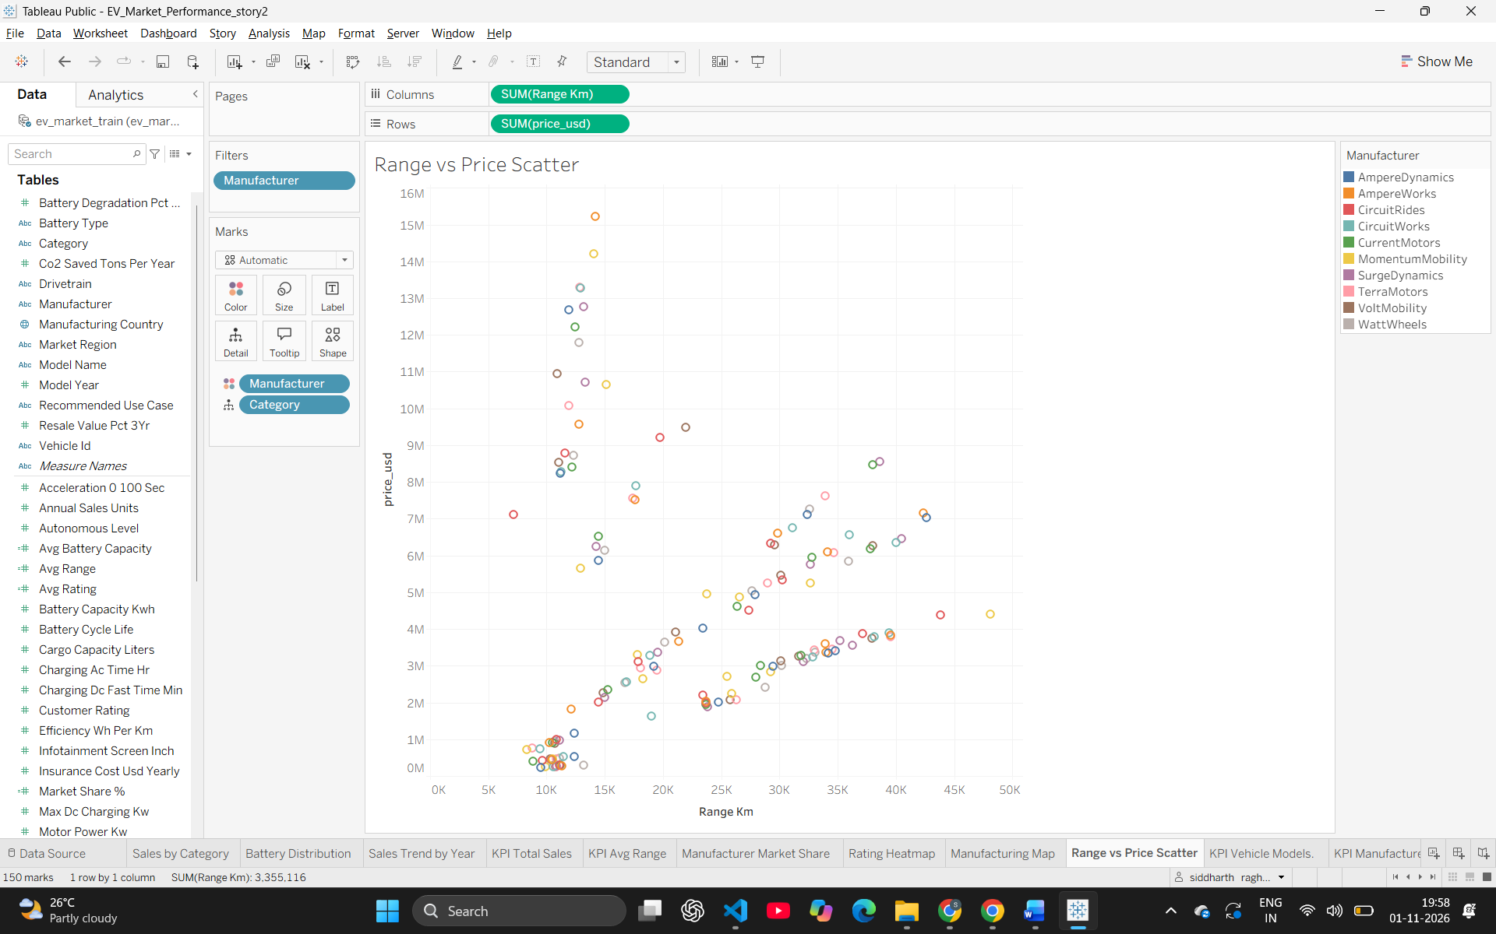
4

